EU Framework on Social Services of Excellence for persons with disabilities

Input of the Taskforce on Quality of Services
Draft Version – October 2022
Table of Contents
1. Rationale 1
2. Introduction 2
3. Overarching Elements for the development of the EU Framework 3
3.1 Setting up the foundations of the framework 5
3.2 Social Services of Excellence as part of a wider system 10
3.2.1 Clear and facilitating legal frameworks 11
3.2.2 Correct and sustainable funding 12
3.2.3 Well-trained and adequate workforce with empowering management/ organisational structures 15
3.3 Framework and accompanying toolkit: design principles and pilot implementation 17
4. Recommendations to the European Commission for the uptake of the EU Framework on Social Services of Excellence 20

Rationale
In March 2021 the European Commission launched the European Strategy for the Rights of Persons with Disabilities, outlining different initiatives that will undertake over the years to come. One of these initiatives, a flagship initiative as it is called, is the development of an EU Framework on Social Services of Excellence for Persons with Disabilities. And more specifically it is stated that “Building on the existing voluntary European Quality Framework for Social Services, the Commission will present, by 2024, a specific framework for Social Services of Excellence for persons with disabilities, to improve service delivery for persons with disabilities and to enhance the attractiveness of jobs in this area including through upskilling and reskilling of service providers.”

The European Association of Service Providers for persons with Disabilities believes that the effective implementation of the Strategy for the Rights of Persons with Disabilities requires partnerships, innovative ideas, and local know-how. Therefore, EASPD set up a taskforce to support in developing input for the European Commission on the development of the EU Framework of Social Services of Excellence. And, with this taskforce, EASPD wishes to follow a co-production approach, by working together with representatives of service providers, of persons with disabilities, of public authorities, international networks, as well as researchers and other relevant stakeholders.

The outcome of this taskforce is this paper that provides a first reflection of the key elements that an EU Framework on Social Services of Excellence needs to include. This will support social services’ move forward towards better quality, empowering and person-centred forms of support, aligned with the UN Convention on the Rights of Persons with Disabilities (hereinafter UN CRPD).

Introduction
Social services encompass services related to care, support, and training, such as childcare, care and support for persons with disabilities and older persons, educational and vocational training, among others. These services aim to prevent situations of risk and vulnerability by improving the living conditions of individuals. They also focus on developing support networks to break down the barriers faced by these individuals and further promote the full enjoyment of their human rights. These services are developed on the basis of social inclusion and “the principles of solidarity and equal access” (Guagliardo and Palimariciuc, 2021). In this sense, they represent a type of Social Services of General Interest (SSGI), which encompass “services provided directly to the person, such as social assistance services, employment and training services, childcare, social housing, or long-term care for the elderly and for people with disabilities” (European Commission, 2013).

For many persons with disabilities, support represents an essential precondition for their active and meaningful participation in society, while preserving their dignity, autonomy, and independence. Thus, support services play a crucial role in further enabling people to fully enjoy their human rights and in empowering people to improve their quality of life. However, services face significant challenges, including those related to the underdevelopment of person-centred and community-based services including personal assistance, outdated infrastructure, staff shortages and poor working conditions and a sector which often offers unattractive work opportunities or work opportunities that are seen as “unattractive”. The demand for care is also continuously increasing but the legal and fiscal policies are not facilitating the response to the complex and evolving needs of individuals. All these and much more, combined with the COVID-19 pandemic, pose threats on the resilience of the social sector.

Consequently, persons with disabilities and other support needs may not have adequate access to support services based in the community and are deprived from fully realising their human rights. However, access to support services alone is not enough, but access to quality support services is what needs to be a priority. This means services that enable people to live independently, while empowering and supporting them to live the lives they want, where they want and with whom they want, with choices and opportunities equal to others. For this to become a reality, it requires both the transition of services from institutional forms of support to person-centred services based in the community and the re-orientation of policies and resources towards this goal.

Additionally, measuring the quality of services for persons with disabilities is a challenging mission for most service providers. The challenges arise not only from the lack of a mutually agreed definition on what quality is but also on how it can be measured and how this process can further support services to improve. Even if, in most of the countries, the assessment of quality in services is set out in legislation, they do not specify methodologies, indicators, and do not define quality, as well as translating the findings into practical recommendations and actions. In certain countries, also, the assessment of quality follows procedures, such as formal inspection visits, that are often closer to administrative processes in nature and do not provide services with the necessary means to develop and improve. However, with this European initiative, there seems to be a general interest, also on the EU level, to improve the quality of services and the assessment processes followed nationally. This is further indicated in the recently published EU Care Strategy and the accompanied Proposal for a Council Recommendation on access to affordable high-quality long-term care where Member States are invited to establish a quality framework for long-term care, further highlighting that “High-quality care services have clear benefits for all ages.”

Overarching Elements for the development of the EU Framework
Setting up the foundations of the framework
- The EU Framework on Social Services of Excellence should encourage the development and delivery of services in line with human rights principles as enshrined in the Convention. This further indicates that the focus, when developing a quality framework, needs to be on the impact that the service has on the quality of life of the people it supports primarily. This is referred to in the literature as outcomes and these outcomes need to be based on rights established in the UN CRPD and centred on the quality of life concept. The emphasis on quality of life of the people receiving care is also highlighted in the recent Proposal for a Council Recommendation on access to affordable high-quality long-term care by the European Commission. There are several indicators (which we will suggest in one of the next chapters) that can be used for this purpose and people’s experiences and perspectives should be at the core of a measurement as such. This combined with indicators that look at the structures of a service, such as the resources available, staff ratio, equipment, facilities among others, as well as processes such as the way support is provided, will help in providing a comprehensive picture of the service’s quality.
- The Framework should apply equally to public, not-for-profit and for-profit service providers.
- It should start with common quality principles, and a common definition of services of excellence, following the principles of the UN CRPD. The lack of a common European definition on quality and quality principles can hinder the development and improvement of services in Member States with non-facilitating policy frameworks and funding opportunities.
- Starting with common quality principles and a common definition of services of excellence will also support Member States in developing high quality services from the outset, making quality an inherent and fundamental aspect of a service. Therefore, this Framework will not only support existing services’ improvement but also in setting out the right foundations for the development of new ones.

Social services of excellence as part of a wider system
- It should also include guidelines towards Member States regarding funding models and policy frameworks that can support reaching the objective. Social Services of Excellence, as a term, should be linked with a human-rights oriented approach. Policy frameworks and funding models can empower and facilitate high-quality services whilst concurrently being sustainable and flexible in the long-term.
- This dictates towards a holistic approach, where services are seen as part of a wider system. Factors, such as community, mindset towards disabilities, accessible mainstream infrastructure, along with policies and funds, should also be considered. In one of the following chapters, we will analyse more the ecosystem within services operate and the important role that this plays in either supporting or hindering the development and improvement of services.

Framework and accompanying toolkit: design principles and pilot implementation
- The design, development and implementation of the framework should be guided by a co-production approach and centralised around the “nothing about us without us” principle. Persons with disabilities, their families and their representative organisations should drive and influence this process, but service providers and their representative organisations should also be at the core of this, with the support of a broad diversity of relevant stakeholders. These stakeholders may include, researchers, policy makers, Member States, regional and local authorities’ representatives, among others.
- Member States with existing Quality Frameworks in place, may be encouraged to take up the EU Quality Framework and its principles, if it is designed in a way that can be integrated or cross-referenced in their existing ones. This was indicated also when the EU Voluntary Framework was published, as mostly countries with non-existing ones were more eager to adopt it.
- The Framework should be developed as a guidance to social services on what they should be working towards helping people achieve while working in a person-centred way, focusing on each person’s needs, preferences and aspirations. This means that the framework needs to result in the services with comprehensive principles and indicators that any tool should include with the aim to increase the awareness of services on what quality is, while also supporting services in continuously improving.
- The Framework should also highlight that any tool that will be used needs to be useful for informing service improvement – not just measuring quality. This is likely to be particularly important to achieve engagement and commitment from service providers, especially if the framework and resulting measures are voluntary. For this to be made possible, as mentioned previously, the framework needs to be accompanied by comprehensive principles and indicators that any tool should include. As well as be accompanied by good practices on quality systems and frameworks for services. These good practices need also to demonstrate how services can use the results of the quality measurement processes to develop action plans that will support them improve in a practical and feasible manner.
- The adoption of the framework by the respective entities needs to be framed in a way that portrays it as advantageous. It should not add a bureaucratic element on the operation of services but be based on partnership, dialogue and collaboration with all relevant stakeholders.
- The Framework and accompanying elements need to be piloted by service providers in different EU countries, and this will raise awareness of the framework and increase the possibility of uptake from Member States. There are different ways to implement this, by organizing workshops and training on the framework, its principles and implementing it through pilot projects across the EU. Funding streams, such as the European Structural funds + and the European Commission’s funding, such as the Employment and Social Innovation programming can realise this goal. It is also interesting to consider that the results of the piloting process can feed into the further development and review of the framework in a later stage.

Setting up the foundations of the framework

The EU Framework on Social Services of Excellence should encourage the development, improvement and delivery of services focusing on a human-rights approach in line with the rights and principles of the Convention. As described previously, when assessing the quality of the service the main priority is to assess the impact that the service generates on the quality of life of the people it supports based on rights established in the UN CRPD. This is in line with human rights standards where services are focused around the needs and preferences of the people they support.

The EU Voluntary Quality Framework on Social Services will be the starting point for the development of the upcoming EU Framework on Social Services of Excellence. The principles underpinned on the Voluntary Framework are an important building block which combined with the long-term care quality principles of the EU Care Strategy, they can set a critical starting point for the further development of a more comprehensive framework of Social Services of Excellence. In the present document we do not refer to these two frameworks since they are developed and well known by and in the European Commission.

The focus of this chapter is on the Quality of Life (QoL) model since it can support in understanding what user’s quality of life is and it can also operationalise the values as underpinned on the Convention, as it is generally agreed that the values of this model align with the values of the Convention. This combined with indicators that focus on the structures and processes of a service, following for example the Quality of Life Supports Model (described below) can help in providing a comprehensive picture of the service’s quality.

There are multiple innovative frameworks developed and implemented in Member States which are combined in a recent study commissioned by EASPD on “Innovative Frameworks measuring the quality of social services for persons with disabilities”. The Quality of Life model and the Quality of Life Supports Model are provided here as examples to emphasize an outcomes oriented and person-centred approach when assessing the quality of services.

UN Convention of the Rights of Persons with Disabilities
The UN Convention on the Rights of Persons with Disabilities (UN CRPD) is an international framework setting out the rights of persons with disabilities. It does not introduce new rights, but it paves the way to a non-discrimination approach towards people with disabilities and their recognition as equal members of the society. It promotes their independence, inclusion, and active participation in the society, while recognizing the need to receive adequate support to fulfill their needs, wishes and preferences. The UN CRPD is legally binding to the countries that have ratified it, it sets out the legal obligations of Member States to protect and promote the rights of persons with disabilities and it calls for reshaping the way services are provided, in a way that is compliant with the CRPD and Human Rights principles.

Implementing the UN CRPD principles as set out in the articles may be challenging. Concepts, such as self-determination, need to be translated to evidence-based practices and specific indicators need to be developed to assess the process of implementing the Convention on a service delivery level. The Quality of life framework provides an opportunity towards this aim, as it is a valid framework that can be used to assess services and systems by focusing on the outcomes that these have on the life of individuals and by bringing the individuals in the heart of the assessment process.

Quality of Life Framework
The Quality of Life framework (QoL) has the potential to give services a focus and a clear set of outcomes that they can work towards supporting people achieve, while ensuring that they focus on each individual in a person-centred way. This framework not only provides support in understanding what Quality of Life is, but it also provides an action-oriented model which can operationalise the values as underpinned on the UN CRPD. Although the original QoL conceptualisation pre-dates the publication of the UN CRPD, it is generally agreed that the values that underpin the QoL framework align with it.

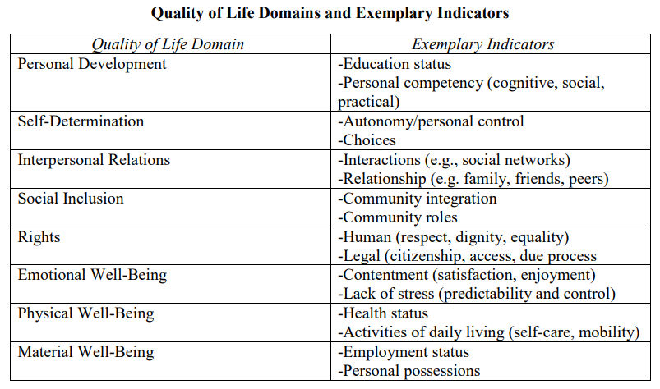
The QoL framework is defined as a state of personal wellbeing that has multiple dimensions and is composed of eight essential domains in the lives of all people. These domains are personal development, self-determination, interpersonal relations, social inclusion, rights, emotional wellbeing, physical wellbeing, material wellbeing and (relevant examples are provided in Figure 1). This framework is universal and cross-cultural, and it supports both to identify how an external person considers the QoL of another person, and the perception of one’s own QoL.

By incorporating the values and principles of the QoL framework into any framework aimed at supporting services improve, we are helping services and their staff to realise that one’s quality of life is composed of multiple domains in their lives. These domains are what constitutes their personal well-being, and these are applicable to all people, regardless of their limitations. So, QoL of an individual is not only if they are healthy and safe, but also for example, if they are supported in making decisions, in having friends, maintaining relationships, having a job etc. Furthermore, this framework supports in considering each individual as a whole person, looking beyond their disability and focusing on their strengths.
Figure 1. Quality of Life Domains and examples of indicators

Quality of Life Supports Model
Building upon the QoL framework, the Quality of Life Supports Model (QoLSM), has emerged in recent years. This model can support in developing and implementing individualised support systems and services for persons with disabilities. It can also work as an evaluation mechanism to investigate the impact of these systems and services on an individual’s quality of life. Currently, this model is used to guide the provision of support, provide a framework for organizational transformation, and encourage systems change.
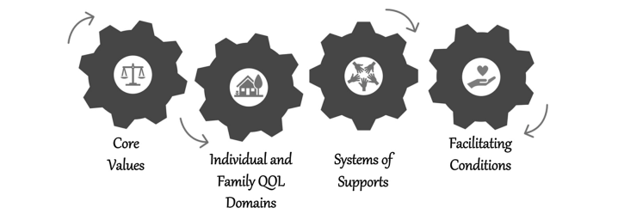
Figure 2. Quality of Life Supports Model

This model encompasses, the new disability paradigm as envisioned in the UN CRPD, it recognizes the capacity of people and their potential to grow and develop, it respects self-determination, inclusion, equity of individuals with disabilities and their families and commits in addressing a person’s support needs while fostering opportunities to further improve people’s well-being. These are what they call the “core values” of the model.

The QoLSM builds upon the Quality of Life individual or family domains which focus on outcomes relevant to the eight domains of the QoL framework that were described above. And each of these domains are aligned with the Articles of the UN CRPD and they support in operationalising the new disability rights paradigm.

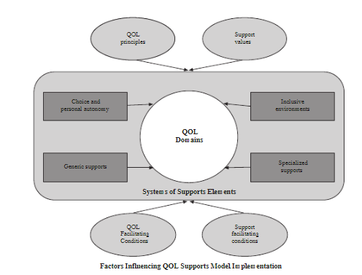
Centralised around the Quality of Life individual or family domains this model identifies the main elements of a supports system. The supports system is a range of resources and strategies that can help in further improving the personal well-being of an individual with a disability and this includes:
- Choice and Personal autonomy, such as the opportunities to make choices and exercise self-determination, facilitated when needed through supported decision-making.
- The development of inclusive environments, where persons with and without disabilities are included and valued, such as supported employment, supported living, inclusive education.
- The development of generic support which is mainstream and accessible to all people, such as technology, prosthetics, lifelong education opportunities, reasonable accommodations.
- The development of specialised support, which refers to the development of support targeted to persons with disabilities and other support needs, such as professionally based intervention, speech therapy, occupational therapy etc.

Organisations that incorporate the QOLSM are integrating the core values of the model within their policies and practices, they are promoting the principles of the QOL framework and its facilitating conditions which involve people’s participation in the community, promoting a sense of belonging, maximizing the person’s capabilities, allowing freedom to engage in major life activities, being committed to the goals that are important to the person and family and respecting differences. They also implement policies and practices based on the principles of supports system, such as availability and accessibility of support, safe and secure environments, information about the elements of a supports systems, competent and knowledgeable support providers and staff, consistency and stability of support provision, and coordination and management of supports.

These demonstrates that the transformation of services requires reforms not only on the service delivery level but also reforms related with policies that can further facilitate the smart transition of social services to more enabling and empowering forms, based on human-rights principles. Consequently, persons with disabilities and other support needs will have access to a comprehensive supports system based on their evolving needs and wishes helping them achieve their dreams and goals in life.

Donabedian’s Structures - Process - Outcomes model
Another model which is commonly used to conceptualise service quality is the Donabedian’s model. This was initially designed for health services, but it has been widely used also in social care services. Donabedian suggested that the quality of services should be judged by the outcomes they produce and identifies three groups whose outcomes should be considered: those who use services, their families and the staff that support them. So, this model suggests that in order to understand and influence outcomes, it is important to understand both the processes and structures in play and following Donabedian’s recommendation, outcomes for staff and families have to also be considered.

Therefore, whilst looking at outcomes was considered paramount, Donabedian highlighted that it was also important to look at:
- the “processes” (sometimes referred to as the “transactions between patients and providers throughout the delivery” of healthcare/or other services – in the context of social care this is usually conceptualised as the type of support provided, as the way the support is provided) and
- the “structures” (sometimes called “inputs”, e.g., the physical and organisational characteristics of the service/organisation including the resources available in terms of staffing, facilities, equipment, expertise, etc.) in place in a service, primarily as it has already been identified that certain processes and structures are more likely to deliver better outcomes for those supported.

Members of the taskforce expressed their concerns when using the Donabedian’s model, as it is mainly used in the healthcare sector and it focuses on quality of care, rather than on the quality of life model. Furthermore, it was indicated that it is not aligned with the UN Convention on the Rights of Persons with Disabilities. Therefore, it was recommended by experts of the taskforce to focus on the Quality of Life concept and the Quality of Life Supports paradigm. However, we have included Donabedian’s model in this chapter to further emphasize the importance of taking a holistic approach when evaluating a service. People’s perspectives should be the starting point, but processes and structures are equally important.

Social Services of Excellence as part of a wider system
The smart transformation of services to more enabling and empowering forms of care and support is becoming a reality. Slowly but steadily many social services are working continuously to ensure equal opportunities for persons with disabilities by guaranteeing the delivery of high-quality support in line with the principles of the UN CRPD. Therefore, it is essential when assessing the quality of social services to take into consideration the broad diversity of situations and legal contexts under which they operate.

The reality is that there are very few examples of legal frameworks in full compliance with the mandates of the Convention across Europe, and that in many cases the funding procedures are restricting services from responding to the evolving needs and wishes of persons with disabilities. These, along with the workforce issues, such as staff shortages, non-attractive job opportunities, low wages, hinder the process of transformation of services towards Social Services of Excellence. With this basis, we aim to emphasize that for an EU Framework for Social Services of Excellence to become a reality there are certain facilitating conditions that need to also be considered:
- Clear and facilitating legal frameworks
- Correct and sustainable funding
- Well-trained and adequate workforce with supportive management/ organisational structures

Clear and facilitating legal frameworks
Since the introduction of the UN CRPD, the role of social services has transitioned from protecting and solely keeping persons with disabilities healthy towards empowering and enabling them to enjoy their rights on an equal basis with others. The Convention, therefore, calls for human-rights, empowering and person-centred forms of support. This transformation of services, however, needs strong foundations and legal frameworks are considered one of them.

There is a big gap between the principles of the UN CRPD, the legal frameworks in EU Member States and the implementation of the Convention on the service provision level. Across Europe, we may identify innovative social services -following the principles of the Convention- with non-compliant legal frameworks or in certain cases even the opposite. Although, this does not suggest putting all the emphasis on policies and losing the scope, which is the actual implementation of the Convention on the service provision level. But rather wishes to emphasize the important role that policies play by either further supporting or restricting the application of the UN CRPD principles on the day-to-day delivery of services.

Supported decision-making for example is becoming a key notion in many Social Services, to empower the people they support to make informed decisions on all aspects of their lives, as endorsed by Article 12 of the Convention. However, most legal frameworks around Europe, apply substitute decision-making approaches, resulting in people having a legal guardian who makes some or all decisions for them, and often without consulting the people themselves. This reality puts pressure and uncertainty on social services and their staff since the legal guardians may not always support the decisions of the individuals under guardianship. Furthermore, making decisions also involves taking risks, and support staff often struggles to find the right balance between ensuring the safety of the person they support and empowering them in enjoying their rights, including their right of making decisions which involve risks. Even more if they are legally responsible for these decisions.

How can supported decision-making be possible when the legal frameworks do not support this reality, do not provide clear guidelines, training and further support to services and their staff to realise the right of the people they support in making decisions? This in no way aims to justify substitute decision-making regimes, this aims to provide clarity on the correlation between national legal frameworks and the impact that they have in the provision of services in line with the principles of the Convention.

Social services need clear and facilitating legal frameworks that enable and empower them to provide support in line with the Convention!

Deinsitutionalisation (DI) reforms is the starting point to develop empowering and enabling support services. Greece is among the Member States in which the European Commission identified the need for DI reforms to create support systems in the community. Greece through the Technical Support on deinstitutionalisation (DI) process in Greece project developed processes and procedures, such as a DI national strategy, a roadmap, and an action plan, to enable the effective implementation of the deinstitutionalisation process.

Another example of facilitating legal frameworks coming from Spain is Law 8/2021 reforming their system into promoting respect for the will and preferences of persons with disabilities and advancing their autonomy. This Law reforms civil and procedural legislation to promote support for persons with disabilities in the exercise of their legal capacity, moving away from the guardianship model.

Scotland introduced the Social Care (Self-Directed Support) Act in 2013 which provided people with care and support needs four options for receiving support. Self-directed support is an approach which puts the person in the centre of planning and can encompass different elements, one of these elements being the user-centred funding model. For instance, persons with long-term care and support needs can choose what kind of support they wish to receive and how they wish to use it. Individuals who have already been assessed as needing a community care service can: Purchase their own support and use a direct payment to pay a person or third party; Direct their own support and the local council will arrange it; Allow the local council to direct and arrange their support or a combination of the previous options.

An additional example is the Legislative Degree of 2017 in Italy for the promotion of inclusive education for students with disabilities. It calls for a person-centred approach with individual plans, the commitment of schools in creating their own inclusion plans – and relative resources, such as budget and school staff. As well as it foresees training on inclusion for all teachers, and inclusion is monitored as a part of the quality criteria.

Correct and sustainable funding
The evolving needs of persons with disabilities and other support needs demand a rather evolving funding model towards social services to support in meeting these needs. The economic decisions taken, as a result of the 2008 financial crisis, contributed to decades of under-funding of services in the field of disability, and the ongoing structural weaknesses of the sector towards quality, innovation, staff shortages and outdated infrastructure. This was brought to light and worsened by the COVID-19 pandemic and its impact also on the financial continuity of many providers of services. A re-think is needed around how much is invested in care and support for persons with disabilities and the continuity of the system itself.

The experience from Europe to date suggests that the type of funding model chosen to support social care services can have a dramatic (and often adverse) impact on services and their quality. For example, in a competitive market (often found in public procurement) where price outweighs quality as a criterion for winning the contract, and regular (sometimes even annual) contract renegotiations result in an entirely short-term approach. It has been characteristic to these models that procedures are made far from people. Individual needs and aspirations are often not taken into account but the procedure is implemented for rather big groups of people. Then service providers are forced to make service offers based on this, without individual considerations. Also, people’s needs and preferences are changing and they might need more or different kind of support than settled in the procurement process. Apart from the negative impact that this has on the people supported, it can create unstable employment for staff, insecure funding for providers and can lead to impossible demands on the capacity of small local providers to cope with delayed cash flows, with re-submission requirements and to create attractive jobs etc.

A Quality Framework should consider key principles for an effective funding mechanism for disability services -setting the right mindset first, safeguard commitment and transparency from public authorities, develop the mechanism based on partnership and dialogue, ensure flexibility and user-centeredness, as well as continuous quality measurement and improvement, and support to build the capacity of stakeholders to understand and transition to new funding models and policies. Currently, there are many initiatives being taken by Authorities to create funding models which promote effectiveness, user involvement and partnership approaches to services for persons with disabilities, which make the most of the significant advantages offered by Europe’s strong network of not-for-profit social services.

Therefore, it is imperative to identify alternative funding models to public procurement that fully consider the needs, wishes of people with disabilities, partnership approaches with not-for-profit social services, while ensuring the sustainability of the services.

Key elements to the funding of community-based care and support services, in line with international human rights standards:
- Mindset first: social services play a crucial role in further enabling people to full enjoy their human rights, in line with the UN CRPD. Therefore, the funding of social services needs to encourage and empower social services in this role.
- Commitment from public authorities to provide adequate and sustainable funding to give services the necessary space to transform their services towards better quality, more empowering and person-centred forms of support. This goes together with Transparency on the rules that define the funding mechanism.
- Based on Partnership and dialogue: developing trust between stakeholders, such as public authorities, service providers, persons receiving support, their family members is a key element to the correct implementation of any policy. This relationship supports in identifying solutions to effectively detect the needs and address challenges.
- Flexible to allow room to services to innovate and support people with disabilities based on a person-centred way, in line with their needs, and wishes. Too often, funding models tend to remove any room for flexibility and innovation as costings are linked to very specific tasks and consequently this has an impact on the support that persons with disabilities receive.
- User-centred to empower persons with support needs to have more choice and control over the care and support they receive, allowing them to meet their individualised needs, wishes and preferences and to live their lives as they want.
- With established Quality and monitoring systems. An effective funding model should be continuously monitored in terms of the quality of its impact over the well-being and quality of life of people it supports and improved accordingly. The Quality and Monitoring systems should also be developed and implemented, in partnership with all relevant stakeholders.
- Providing the right Support and capacity-building mechanisms to ensure that all stakeholders have the right understanding and support to use the new policy in the best possible way.

Promising examples of funding models across Europe:
- Personal Budgets is an innovative funding model gaining the attention of public authorities across the EU. Sweden for example is one of the first countries to introduce the Personal Assistance Budget (PAB) in their national law and in 1993, similarly in the Netherlands, since 1995. In Flanders, Belgium the personal financing has been introduced since 2016. Many other EU countries, such as Ireland, Austria, Spain, and Finland have started pilot projects related to the personal budgets funding model.
- Partnership models: In 2017 in Italy the “Code of the Third Sector” was enacted, introducing alternative models to public procurement for the provision of social services. Through a model of partnership and collaboration between services and public authorities there is a 3-step model that is implemented.
  - Through co-programming the services together with the public authorities are investigating to identify the societal needs, the key areas of actions and the resources available.
  - Followed by project co-development, they define the services/ interventions that are needed to meet the needs that they were identified during the co-programming stage. This is mainly happening through roundtable meetings between services and public authorities.
  - Lastly, during the accreditation phase, the services with whom the public authorities will activate the project co-development partnership are identified.

Well-trained and adequate workforce with empowering management/ organisational structures
Support professionals are the foundation of social services. They are key to the development and further functioning of the services, and they can fulfill their important role if they are well-trained and in sufficient numbers. Training professionals is considered also one of the key principles for promoting implementation of the Convention. Yet one of the consequences of the underfunding of social care is precisely the cuts to expenditures around the training of staff, as well as the diminishing number of trained staff available.

The social care and healthcare sectors have the potential of creating 8 million new jobs over the next decade. However, we are far from making the most out of this potential. Staff shortages have exacerbated after the COVID-19 pandemic, with many moving towards the healthcare sector and better paid positions, often in other EU countries. The lack of attractiveness of the sector, poor working conditions, often absent career, and knowledge advancement opportunities further contribute to this trend. The sector also struggles to attract men and it also relies on migrants, either from within or outside of the European Union. The single most important element and challenge in social service provision is staff and the detrimental impact all these challenges can have on the transition to person-centred and community-based forms of care and support (rather than institutional), in line with the UN CRPD, cannot be underestimated.

Here we will include a paragraph on empowering management and organisational structures. As well as examples below.

The implementation of the Convention relies on the sector’s ability to recruit, retain, and train the growing pool of workers with the required skills!

- Working time reduction: In Austria, after the pandemic hit the country, a three-year agreement between the social partners was found in April 2020. The social partners agreed to wage increases for 2020 and 2021, and to a working time reduction to 37 hours from 1 January 2022 onwards. This agreement is considered a milestone by the unions. In addition to the efforts of the private sector, the City of Vienna has started a 3-year evaluation of working time for the public sector. The public-sector union will accompany this evaluation and will show the specific needs of the different health and social care sectors. For health professions, more factors than working time should be considered to improve working conditions and ensure a high-quality care - the promotion of training and further education, as well as making the various professions more attractive will be also considered.
- The promotion of social dialogue between employers and workers representatives in social care services is crucial. The European Commission, as communicated in the recent European Care Strategy, recognizes that strong social dialogue together with better working conditions, wages, education and training can make jobs more attractive and it will continue explore the setup of a sectoral social dialogue for social services at EU level. Social dialogue structures in the sector are often weak, in particular (but not only) in Central and Eastern Europe. Even at EU level today, there is still no sectoral social dialogue committee for social services, including social care. In Flanders for example, agreements between employer and employee organisations and the Flemish Government are made to improve working conditions, since 1998. These Flemish Intersectoral Agreements (VIA) are framework agreements that can then be concretised in collective agreements. In 2021, this resulted in wage increases and additional staff. There will also be an action plan for the inflow of new employees and measures for better working conditions.
- Promising examples of trainings:
  - The European Care Certificate (ECC) is a Europe-wide qualification which covers the basic knowledge that is required for an individual to work in a health and social care setting. The ECC is aimed at trainers, employers, and staff in the sector. After completion of the training and successful pass of the exam, participants receive a certification and are recorded on a central database.
  - The WHO QualityRights initiative is an online training with the goal to change mindsets and practices in a sustainable way and empower all stakeholders to promote rights and recovery to improve the lives of people with psychosocial, intellectual, or cognitive disabilities everywhere.

Framework and accompanying elements: design principles and pilot implementation
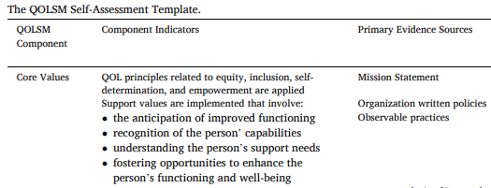
- The development of an accompanied document with examples of existing tools (see Figure 3) that can be tailored to specific services and persons with support needs can encourage the uptake of the framework. Different tools can support in assessing different aspects of a service and measurement instruments can be specific to different target groups and services. Therefore, the EU Framework on Social Services of Excellence should result in the development of practical recommendations accompanied by examples that can be used in different countries.
Figure 3. Example of a tool, the QOLSM self-assessment template

- To further support gathering information about people’s lived experiences and particularly in relation to people with severe and profound intellectual disabilities it is essential that outcomes are clearly operationalised and in a way that can be applied to ALL people with disabilities, including those with severe and profound disabilities.
- This is also why observational methodologies (what someone will see when visiting a service) are equally important as a tool (see Figure 4). This can be facilitated with the introduction of experts by experience -persons with disabilities- in the quality monitoring processes within Member States. Furthermore, this in no way denies the importance of capturing the subjective experiences of people with profound disabilities, when possible. It further aims to showcase that this can explore both the lived experiences of people who use services and looking at the quality of support and the practices and processes in use within services.
Figure 4. Example of observational indicators

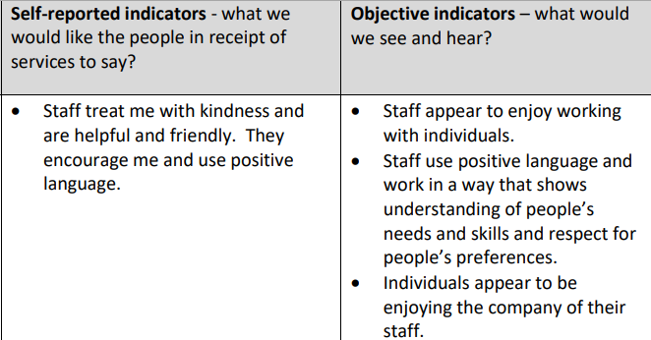
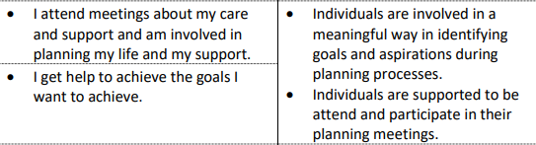
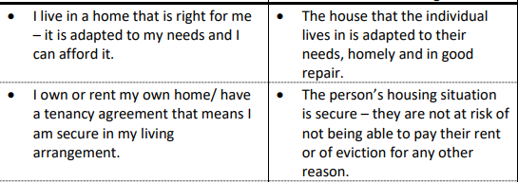
- It is therefore essential to acknowledge the need for “triangulation” of different sources of evidence on service quality. We need to combine subjective measures that look at what is important to people and how they experience life and the services they receive, with objective indicators, that will usually require observation methodologies. These indicators (see figure 5) ensure that needs are being met and that people have the same rights and opportunities as people without disabilities along with the support they need to realise those rights and make the most of the opportunities available to them. Howewer, we cannot rely only to objective indicators based on observation methodologies, since these can also be subjective. Therefore, it is important to combine also other type of objective indicators, such as statistical information on the standard of living for persons with disabilities, access to labour market, independent living and inclusion in the community etc.
Figure 5. Examples of objective & subjective indicators

- The framework should be accompanied by good practices on quality systems/ frameworks for services, as mentioned previously. This will further support Member States with practical examples in encouraging services to develop and improve through quality measuring frameworks, as it is often not only the lack of political will/ commitment that puts a stop in realizing this, but also the lack of know-how to implement such fundamental changes.

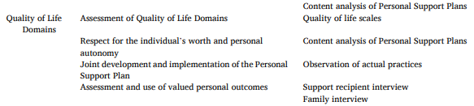
- A participatory approach towards service evaluation should be followed. Persons using the services, their families and the staff members should be involved when assessing the quality of services. An outcomes-oriented approach to services quality directs towards looking on the outcomes it produces for the people it supports but also those of their family members (wherever applicable) and the support staff’s.
Figure 6. Example of a participatory approach tool

Figure . Example of a tool, the QOLSM self-assessment template

- The uptake of the framework across the EU can further increase via pilot implementation (see Figure 7). This will support in the development of a framework and accompanied toolkit that:
  - is flexible enough to be integrated in existing frameworks and support in improving them or in the development of a framework in Member States with non-existing ones
  - raise awareness on the framework across regions and more local contexts to further increase its uptake
  - compile results from the pilot implementation that will support in a later review process of the framework developed by the European Commission.

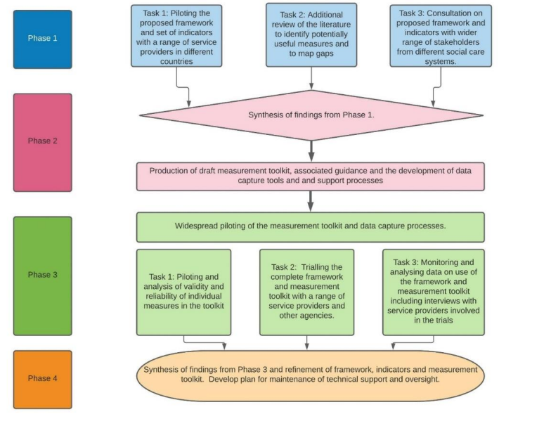
Figure 7. Recommended process for the development of the EU framework

Recommendations to the European Commission for the uptake of the EU Framework on Social Services of Excellence
- The EU Framework on Social Services of Excellence initiative should be interlinked with other initiatives (existing and upcoming), such as the EU Care Strategy and the Guidance towards Member States on Independent Living and Inclusion in the Community. It should also pave the way for the development of other relevant initiatives and funding programmes which can support its uptake by Member States and Social Services.
- A mechanism to facilitate and support the implementation of the Framework needs to be developed. This can be further promoted by the creation of a working group within the Disability Platform or the Social Protection Committee. The creation of this working group can accompany the work of the European Commission from the development of the framework to facilitating and monitoring its implementation. This working group should include persons with disabilities, their families and representative organisations, service providers and representative organisations, as well as other relevant stakeholders. This work requires a co-production approach generating partnerships, innovative ideas, and local know-how whilst respecting the roles and responsibilities of the different stakeholders. The Strategic Dialogues, along with the co-production approach during the development of the framework can also increase its future take up.
- This working group can also facilitate in monitoring the progress of the implementation of the Framework in different Member States. Research grants can be created to support the group in identifying how the uptake of the framework is progressing after a period of 2-3 years after its publication.
- EU funds could be used to facilitate the take up of the Framework. This could initially start though an EU funded project piloting the framework in social services in several European Countries (see Figure 7) resulting also in recommendations for scaling and take up throughout the EU. Following this the European Social Fund+ and the Support for Reform program can be used by managing authorities to support the implementation of the Framework in a more medium term, before transitioning to national and regional funding programmes.
- A dissemination and exploitation strategy from the European Commission may also support in increasing the awareness of the Framework among Member States and other relevant stakeholders.
- Additional research is needed at EU level, to better understand the development of services across Europe. There are important data gaps at EU level, related to quality, staff shortages, accessibility, and affordability of services, among others, which hinder the development and improvement of services. Research grants that can also be used to enhance collaboration between different stakeholders, including people with disabilities, and this can also support to improve the quality of services. The program 'Onbeperkt meedoen' specifically in the Netherlands promotes the implementation of the UN CRPD by funding disability research on education, work, and healthcare. At the EU level this can be financed under the Horizon Europe program for research and innovation, together with the creation of a Knowledge Hub for exchange and transferability of good practice.
- The European Commission can support Member States by providing them with practical recommendations, such as:
  - developing the assessment of quality of services in Member States not only as an overarching objective but also with definitions and methodologies specified, following the principles and indications of the EU Framework of Social Services of Excellence. This indicates a comprehensive quality framework focused primarily on the quality of life of the people with disabilities and other support needs but looking also on structures and processes.
  - implementing training programmes on the framework, its principles (aligned with the UN CRPD), and indicators to accomplish its uptake within Member States in different levels, national, regional, and local. These training programmes should also include persons with disabilities as trainers and trainees. These training programmes can be further advanced through the development of hands-on trainings on the implementation of the principles of the framework on the day-to-day operation of services. This should also include elements relevant to the management of services to adequately drive towards a management culture seeking ongoing quality assessment of services and building upon the results. In addition, it should be linked with training programmes, such as the rights and principles of the UN CRPD, person-centred support, supported decision-making etc as a continuation of the framework training to frontline staff. The Erasmus + funding program can be supportive to reach this objective.
  - setting up a coordination agency within the Ministry encouraging cooperation between Ministries and between central and local authorities as this can support and promote the EU Framework on Social Services of Excellence, while ensuring the provision of high-quality services nationally.
- The European Commission can support in highlighting the added value that the Framework can bring in the Member States, including for authorities and service providers.
  - High-quality services, as indicated on the EU Care Strategy, have clear benefits for all ages. From early childhood intervention to care and support services for older people, services play a crucial role in enabling and empowering people to live in dignity, fully enjoy their human rights and improve their quality of life based on their needs and wishes. High-quality services can prevent insitutionalisation or the need for increased support later in life, reduce the pressure and responsibility of care that may be experienced by family and informal carers, as well as providing them with more life choices, career options and work-life balance. Therefore, high-quality services have benefits not only for the people in need of care and support but also for their carers and a positive impact to the society.

Quinn, Gerard. (2016). Report on access to rights-based support to persons with disabilities. A/HRC/34/58. United Nations Human Rights Office of the High Commissioner. Available here: https://www.ohchr.org/en/calls-for-input/report-access-rights-based-support-persons-disabilities
EASPD. (2021) Innovative frameworks for measuring the quality of services for persons with disabilities. Brussels. Available here: https://www.easpd.eu/publications-detail/report-on-innovative-frameworks-for-measuring-the-quality-of-services-for-persons-with-disabilities/
European Commission. (2022). A European Care Strategy for caregivers and care receivers. Brussels. Available here: https://ec.europa.eu/commission/presscorner/detail/en/ip_22_5169
Gómez L., Asunción Monsalve A., Morán L., Alcedo A., Lombardi M., Schalock R. (2020). Measurable Indicators of CRPD for People with Intellectual and Developmental Disabilities within the Quality-of-Life Framework. International Journal of Environmental Research and Public Health.
EASPD (2021) Innovative frameworks for measuring the quality of services for persons with disabilities. Brussels. Available here: https://www.easpd.eu/publications-detail/report-on-innovative-frameworks-for-measuring-the-quality-of-services-for-persons-with-disabilities/
Ibid
Ibid
ibid
ibid
Schalock R. (2020) The Quality of Life Supports Model: Components and Applications, Keynote Address: 17th International Conference on Positive Behavior Supports. Miami, Florida. Available here: https://www.apbs.org/conference/files/2020presentations/Keynote-Schalock-text.pdf
Schalock, R.L. & Verdugo, M.A. (2002) Handbook on Quality of Life for human service practitioners. Washington DC: American Association on Mental Retardation
Schalock R. (2020) The Quality of Life Supports Model: Components and Applications, Keynote Address: 17th International Conference on Positive Behavior Supports. Miami, Florida. Available here: https://www.apbs.org/conference/files/2020presentations/Keynote-Schalock-text.pdf
ibid
Gomez L., Verdugo M. (2021) A quality of life supports model: Six research-focused steps to evaluate the model and enhance research practices in the field of IDD
EASPD (2021) Innovative frameworks for measuring the quality of services for persons with disabilities. Brussels. Available here: https://www.easpd.eu/publications-detail/report-on-innovative-frameworks-for-measuring-the-quality-of-services-for-persons-with-disabilities/
EASPD (2019). DI Greece: Technical Support on deinstitutionalisation (DI) process in Greece. Available here: https://www.easpd.eu/project-detail/di-greece-technical-support-on-deinstitutionalisation-di-process-in-greece/
EASPD (2021). Models on innovative practices focusing on supported decision-making mechanisms. Brussels. Available here: https://www.easpd.eu/publications-detail/models-on-innovative-practices-focusing-on-supported-decision-making-mechanisms/
Social Care (Self-directed Support) Scotland, Act 2013. Available here: www.legislation.gov.uk/asp/2013/1/contents
Legislative Degree no 66 of 2017: https://www.gazzettaufficiale.it/eli/id/2017/05/16/17G00074/sg
EASPD (2020). Funding of disability services in Europe: a state of play. Brussels. Available here: https://www.easpd.eu/fileadmin/user_upload/EAS_007-21_Study_on_funding_v2.pdf
EASPD (2019). How to Fund Quality Care and Support Services: 7 key elements. Brussels. Available here: www.easpd.eu/fileadmin/user_upload/Bucharest_2019_conference_report__2.pdf
Ibid
UNICproject (2021). Models of Good Practice Report on Personal Budgets. Brussels. Available here: https://www.unicproject.eu/wp-content/uploads/2021/09/2.1-Models-of-Good-Practices-report.pdf
EASPD - Sidley Austin LLP. (2022) Memorandum on Alternative models for the provision of social services in the European Union, unpublished.
Article 4 of the UN CRPD on General Obligations of States Parties. Available here: https://www.un.org/development/desa/disabilities/convention-on-the-rights-of-persons-with-disabilities/article-4-general-obligations.html
EASPD (2021). EASPD Position Paper on the EU Care Strategy. Brussels. Available here: https://www.easpd.eu/fileadmin/user_upload/EU_Care_Strategy_EASPD_Position_Paper.pdf
EASPD (2019). Staff Matters: From care worker to enabler of change. Brussels. https://www.easpd.eu/fileadmin/user_upload/EASPD_Helsinki_Conference_Report_2019.pdf
Federation of European Social Employers (2022). New report: Impact of Covid-19 on the social services sector and the role of social dialogue. FORESEE project. Brussels. Available here: https://socialemployers.eu/en/news/new-report-impact-of-covid-19-on-the-social-services-sector-and-the-role-of-social-dialogue/
European Care Certificate. Available here: eccertificate.eu
WHO (2019). Quality Rights materials for training, guidance and transformation. Available here: www.who.int/publications/i/item/who-qualityrights-guidance-and-training-tools
EASPD (2021) Innovative frameworks for measuring the quality of services for persons with disabilities. Brussels. Available here: https://www.easpd.eu/publications-detail/report-on-innovative-frameworks-for-measuring-the-quality-of-services-for-persons-with-disabilities/
The UNIC project will develop a guide on how to train and support peer-to-peer interview processes to measure the quality of personal budgets. The guide will be ready in the end of 2022 and the link will be shared here as well.
EASPD (2021) Innovative frameworks for measuring the quality of services for persons with disabilities. Brussels. Available here: https://www.easpd.eu/publications-detail/report-on-innovative-frameworks-for-measuring-the-quality-of-services-for-persons-with-disabilities/
EASPD (2021) Innovative frameworks for measuring the quality of services for persons with disabilities. Brussels. Available here: https://www.easpd.eu/publications-detail/report-on-innovative-frameworks-for-measuring-the-quality-of-services-for-persons-with-disabilities/

